1. **Filtering Using RANdom SAmple Consensus (RANSAC) Approach.**

The ICESat-2 elevation data included many outliers, mostly caused by cloud cover. However, elevation changes from glacier surges can also look like outliers. Because of this, a simple thresholding method like removing all points where the elevation difference (Δh) is above a certain value would likely remove both the unwanted cloud points and the critical surge signals. To help separate these different types of data, we compared ICESat-2 elevation with elevation from a digital elevation model (DEM). When plotted, this shows three groups: one that follows the glacier surface, one that is much higher (clouds), and one that is slightly offset (possible surge signals).

We needed a method that worked well across many different glaciers. For this, we used the RANSAC method to detect and remove outliers. RANSAC works by finding a line that fits the main glacier surface points, while ignoring those that don’t fit (like clouds and surge points). Points within a threshold distance from this line were considered inliers. This allowed us to clean the data in a way that kept real glacier changes while removing most of the unwanted noise. The figures below show how RANSAC was used and how it improved the data quality. The method itself generally worked, however, it is important to note that some glaciers still contained a lot of noise, while on some very pronounced surges, some parts of the surge were removed (Wahlenbergbreen). It was, however, the most effective method for the whole dataset.

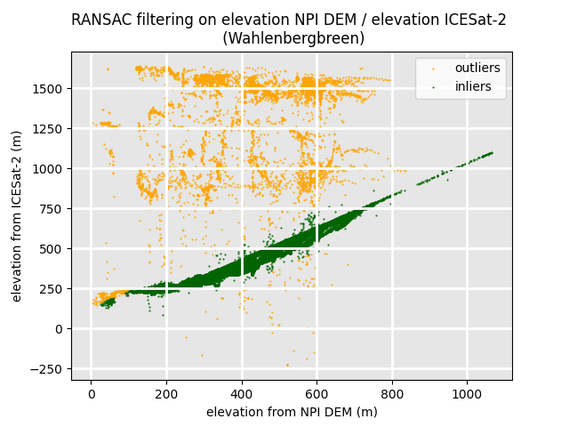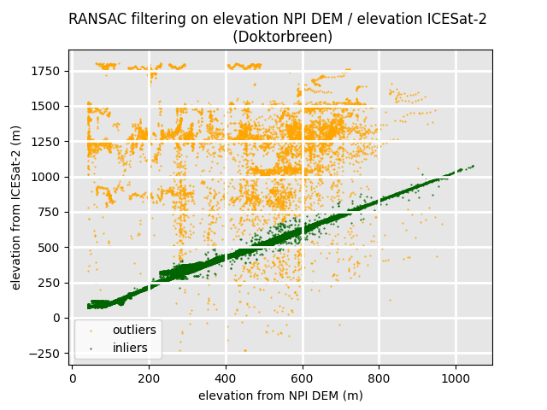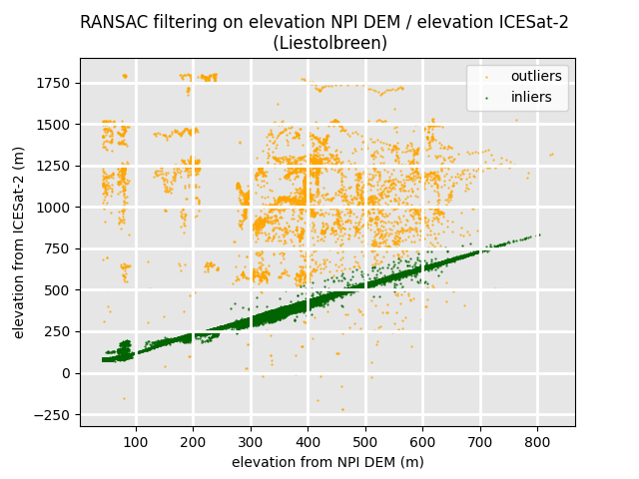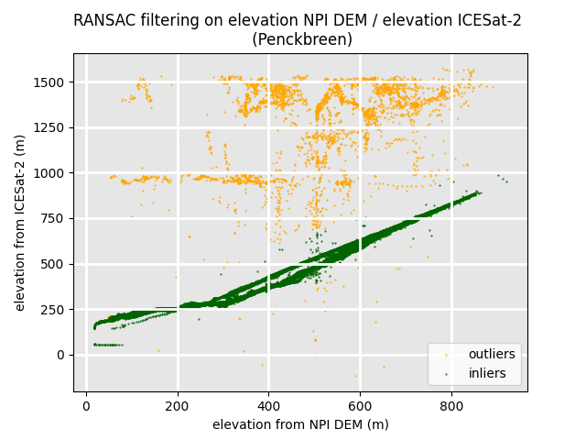

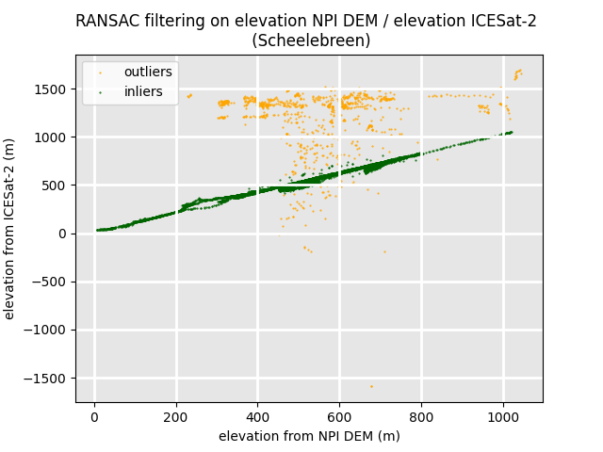

1. **Feature Extraction**

The features that were used for the Random Forest classification were briefly introduced in the main article. This supplementary section provides a more detailed explanation of all statistical features that were extracted, considered, and the motivation behind their use.

As established, a surge plot displays DEM-derived elevation on the x-axis and elevation change (dh) on the y-axis. In non-surging glaciers, these plots typically show consistent patterns: slight elevation gain in the accumulation zone and slight elevation loss in the ablation zone. Surging glaciers, on the other hand, exhibit chaotic behaviour – significant elevation gain in the lower parts and corresponding elevation loss in the upper parts, with no consistent magnitude.

The elevation data were normalized prior to analysis. Glaciers were divided into elevation bins, each representing 5% of the glacier’s elevation range based on the DEM. This binning serves two purposes: to (1) ensure each part of the glacier contributes equally to the classification, avoiding dominance by high-elevation zones (which typically contain more data points), and (2) to allow for more consistent comparisons across different years. The lowest and highest elevation bins were excluded due to high error rates.

To identify surge-type glaciers using elevation change data we selected a set of statistical features designed to capture the distinct patterns associated with glacier surges. These features emphasize how both elevation and elevation change vary, with particular attention to the lower portion of the glacier, where surge-related surface changes are typically most pronounced. The following section details each feature, the rationale behind its inclusion, and how its values tend to differ between surging and non-surging glaciers.

**95th percentile of elevation change in the lower part** *(dh_max)***.** The 95th percentile highlights the extreme positive changes. Surging glaciers often show large increases in surface elevation due to ice pushing into the lower glacier. The Obsah obrázku text, snímek obrazovky, diagram, Vykreslený graf
motivation for using this metric is that it should differentiate between surging and non-surging glaciers by a slightly negative value for non-surging glaciers, and a largely positive value for surging glaciers. The histogram shows this general trend. Nearly all non-surging glaciers stay near or below 0, while surging glaciers can have extreme positive values. There are some negative values for the surging glaciers as well. This might be caused between the difference between the acquisition time of the DEM and ICESat-2, which came well over 10 years later. It is possible that some glaciers lost a lot of mass after the DEM acquisition, then surged, gained mass, but still not enough to account for the Obsah obrázku text, snímek obrazovky, diagram, řada/pruh
mass loss in between the DEM acquisition and the surge.

**Mean elevation change in the lower part of the glacier** *(dh_mean_l)***.** This one is similar to the 95th percentile, however, it is more focused on a “trend” than a single value. The idea is similar though – this metric should be negative for non-surging glaciers and positive for surging glaciers. This one is, however, more complicated and the values largely overlap. Even on a surging glacier, parts of the ablation zone may be experiencing elevation loss, pushing the average to negative values.

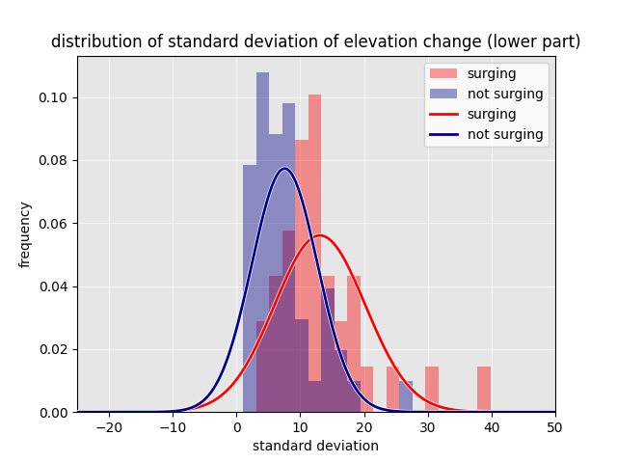

**Standard deviation of elevation change in the lower part of the glacier** *(std_dev)***.** This value might tell us about how much the elevation change is scattered, how large the difference is between the highest and lowest values. A stable glacier should have a low standard deviation, because the elevation change should be slightly negative throughout the ablation zone. Surging glaciers should have elevation changes in the ablation zone scattered all over the place, therefore showing a higher standard deviation. The distribution plot does not show dramatic differences between the categories.

**2D standard deviation of elevation and elevation change for the lower part of the glacier** *(hdh_stddev_l)***.** The 2D standard deviation was used to computed standard deviation for x = elevation and y = elevation change. The motivation was to see if the values spread in one direction or are more scattered all over the place (indicating a surge).

**Linear regression coefficient on the binned data** *(linreg_coef_binned)***.** The slope of the data was computed on the binned data using a linear regression. Typically, stable glaciers will have a positive slope (as explained before – accumulation in accumulation zone and ablation in ablation zone). Surging glaciers will have this completely the other way around as mass is transported from the upper parts towards the terminus. The slope was computed on the binned data to give the same weight to the narrow tongue (which contains less points) and the accumulation zone which is typically wider (contains more points).

**Linear regression coefficient on the binned data in the lower part of the glacier** *(linreg_coef_l_binned)***.** The same was done for the lower part of the glacier, where surges are most pronounced.

**Residuals of linear regression** *(residuals)***.** The residuals are computed as the sum of squares of the linear regression on the binned data. This metric is supposed to say how far the data is Obsah obrázku text, snímek obrazovky, diagram, Vykreslený graf
scattered from the line. Generally, non-surging glaciers should be close to the line, if the data does not contain noise. On surging glaciers, however, the points should be more scattered all over the place (it is likely that a linear regression is not the optimal regression to fit to the data), resulting in higher residuals.

**RANSAC coefficient** *(ransac)***.** The RANSAC regression coefficient was computed in order to calculate the trend of the data without potential noise. This was not computed on the binned data but on the actual ICESat-2 data points, to see the general trend of the elevation change per elevation. Typically, normal glaciers that are melting will have a slightly positive RANSAC coefficient when the glacier has lost mass in the ablation zone and gained mass in the ablation zone. A very prominent surge will have the opposite signature (large accumulation in the lower part and mass loss in the upper part of the glacier), causing the RANSAC coefficient to be very negative. It can be, however, problematic when the surge is labeled as noise – then the value of a surging glacier is similar to a non-surging one.

**RANSAC coefficient for the lower part of the glacier** *(ransac_l)***.**

**Count of points above 15m elevation change in the lower part of the glacier** *(over15)***.** These points should indicate a surge, however, could also be noise. The thought is that a surging glacier will have many more points above 15 m elevation change in the lower part, whereas if it is noise, it will just be isolated values. However, only the massive surges had many points over 15m, small surges did not have almost any.

**Averages of the hypsometric bins** *(bin1, …, bin18)***.** The largest differences between surging and non-surging glaciers are visible in the lower bins (1 and 2) where surging glaciers often have larger average values and then in bins 5-14 where surging glaciers often have lower values than non-surging glaciers. In the upper-most bins there are no visible differences between the distributions.

**Maximum elevation change value of the bins in the lower part of the glacier** *(bin_max)***.** The maximum value from the bin averages in the lower part of the glacier is saved as a separate variable in order to enhance the influence of the bin where the surge is most pronounced.

1. **Training Data**

|  |  |  |  |
| --- | --- | --- | --- |
| **training data for analysis for 5-year data** | | | |
|  | **name** | **glacier_id** | **surging** |
| **0** | Austfonna-Basin3 | G024340E79634N | 1 |
| **1** | Arnesenbreen | G018098E77802N | 1 |
| **2** | Nathorstbreen | G016633E77290N | 1 |
| **3** | Sonklarbreen | G020098E78757N | 1 |
| **4** | Markhambreen | G017096E77164N | 1 |
| **5** | Recherchebreen | G015037E77377N | 1 |
| **6** | MorsjnevStrongbreen | G017697E77678N | 1 |
| **7** | Kvalbreen | G018031E77579N | 1 |
| **8** | Ganskijbreen | G020757E78746N | 1 |
| **9** | Negribreen | G018042E78675N | 1 |
| **10** | Tunabreen | G017497E78572N | 1 |
| **11** | Osbornebreen | G013139E78668N | 1 |
| **12** | Monacobreen | G012697E79319N | 1 |
| **13** | Stonebreen | G023608E77828N | 1 |
| **14** | Penckbreen | G015616E77394N | 1 |
| **15** | Scheelebreen | G016964E77694N | 1 |
| **16** | Vallakrabreen | G017158E77876N | 1 |
| **17** | Liestolbreen | G016915E77433N | 1 |
| **18** | Svalisbreen | G016777E76955N | 1 |
| **19** | Midtbreen | G016346E79525N | 1 |
| **20** | Bakaninbreen | G017525E77773N | 0 |
| **21** | Andrebreen | G011158E79339N | 0 |
| **22** | Mayerbreen | G012572E79241N | 0 |
| **23** | Kollerbreen | G012352E79323N | 0 |
| **24** | Elnabreen | G014132E79125N | 0 |
| **25** | Sjettebreen | G011294E79478N | 0 |
| **26** | Karlsbreen | G013347E79296N | 0 |
| **27** | FjortendeJulibreen | G012363E79148N | 0 |
| **28** | Holmstrombreen | G013749E78857N | 0 |
| **29** | Lisbetbreen | G014909E79069N | 0 |
| **30** | VonPostbreen | G017824E78480N | 0 |
| **31** | VestreTorrellbreen | G015026E77342N | 0 |
| **32** | Steenstrupbreen | G016290E77607N | 0 |
| **33** | Inglefieldbreen | G017911E77804N | 0 |
| **34** | Andrinebreen | G018010E77975N | 0 |
| **35** | Jinnbreen | G017562E78141N | 0 |
| **36** | Hinlopenbreen | G018391E78924N | 0 |
| **37** | Oslobreen | G018173E79037N | 0 |
| **38** | Tryggvebreen | G016733E79123N | 0 |
| **39** | Marsjobreen | G022215E77928N | 0 |
| **40** | Kvitisen | G021454E78071N | 0 |
| **41** | Duckwitzbreen | G021120E78374N | 0 |
| **42** | Freemanbreen | G021590E78354N | 0 |
| **43** | VegafonnaMariebreen | G021009E79425N | 0 |
| **44** | Usherbreen | G018580E78256N | 0 |
| **45** | Nordmannsfonna | G018296E78282N | 0 |
| **46** | Hockstatterbreen | G019758E78902N | 0 |
| **47** | Tommelbreen | G018473E79506N | 0 |
| **48** | Svitdjodbreen | G011686E79700N | 0 |
| **49** | Kuhrbreen | G021849E77617N | 0 |
| **50** | Vitkovskibreen | G016292E76781N | 0 |
| **51** | Slakbreen | G016584E77967N | 0 |
| **52** | Dunerbreen | G016909E79728N | 0 |
| **53** | Morabreen | G014184E78936N | 0 |
| **54** | Forstebreen | G011244E79295N | 0 |
| **55** | Waggonwaybreen | G011437E79514N | 0 |
| **56** | Smerenburgbreen | G011600E79552N | 0 |
| **57** | Chauveaubreen | G011912E79647N | 0 |
| **58** | Raudfjordbreen | G012020E79575N | 0 |

|  |  |  |  |  |
| --- | --- | --- | --- | --- |
| **training data for analysis done by hydrological year** | | | | |
|  | **name** | **glacier_id** | **year** | **surging** |
| **0** | Austfonna-Basin3 | G024340E79634N | 2019 | 1 |
| **1** | Austfonna-Basin3 | G024340E79634N | 2020 | 1 |
| **2** | Austfonna-Basin3 | G024340E79634N | 2021 | 1 |
| **3** | Austfonna-Basin3 | G024340E79634N | 2022 | 1 |
| **4** | Austfonna-Basin3 | G024340E79634N | 2023 | 1 |
| **5** | Arnesenbreen | G018098E77802N | 2019 | 1 |
| **6** | Arnesenbreen | G018098E77802N | 2020 | 1 |
| **7** | Arnesenbreen | G018098E77802N | 2023 | 1 |
| **8** | Nathorstbreen | G016633E77290N | 2019 | 1 |
| **9** | Nathorstbreen | G016633E77290N | 2020 | 1 |
| **10** | Nathorstbreen | G016633E77290N | 2021 | 1 |
| **11** | Nathorstbreen | G016633E77290N | 2022 | 1 |
| **12** | Nathorstbreen | G016633E77290N | 2023 | 1 |
| **13** | Sonklarbreen | G020098E78757N | 2020 | 1 |
| **14** | Sonklarbreen | G020098E78757N | 2021 | 1 |
| **15** | Sonklarbreen | G020098E78757N | 2022 | 1 |
| **16** | Sonklarbreen | G020098E78757N | 2023 | 1 |
| **17** | Markhambreen | G017096E77164N | 2019 | 1 |
| **18** | Markhambreen | G017096E77164N | 2020 | 1 |
| **19** | Markhambreen | G017096E77164N | 2021 | 1 |
| **20** | Markhambreen | G017096E77164N | 2023 | 1 |
| **21** | Recherchebreen | G015037E77377N | 2019 | 1 |
| **22** | Recherchebreen | G015037E77377N | 2020 | 1 |
| **23** | Recherchebreen | G015037E77377N | 2021 | 1 |
| **24** | Recherchebreen | G015037E77377N | 2022 | 1 |
| **25** | Recherchebreen | G015037E77377N | 2023 | 1 |
| **26** | MorsjnevStrongbreen | G017697E77678N | 2020 | 1 |
| **27** | MorsjnevStrongbreen | G017697E77678N | 2021 | 1 |
| **28** | MorsjnevStrongbreen | G017697E77678N | 2022 | 1 |
| **29** | MorsjnevStrongbreen | G017697E77678N | 2023 | 1 |
| **30** | Kvalbreen | G018031E77579N | 2020 | 1 |
| **31** | Ganskijbreen | G020757E78746N | 2019 | 1 |
| **32** | Ganskijbreen | G020757E78746N | 2020 | 1 |
| **33** | Negribreen | G018042E78675N | 2019 | 1 |
| **34** | Negribreen | G018042E78675N | 2020 | 1 |
| **35** | Negribreen | G018042E78675N | 2021 | 1 |
| **36** | Negribreen | G018042E78675N | 2022 | 1 |
| **37** | Negribreen | G018042E78675N | 2023 | 1 |
| **38** | Tunabreen | G017497E78572N | 2019 | 1 |
| **39** | Tunabreen | G017497E78572N | 2020 | 1 |
| **40** | Tunabreen | G017497E78572N | 2021 | 1 |
| **41** | Tunabreen | G017497E78572N | 2022 | 1 |
| **42** | Tunabreen | G017497E78572N | 2023 | 1 |
| **43** | Osbornebreen | G013139E78668N | 2020 | 1 |
| **44** | Osbornebreen | G013139E78668N | 2021 | 1 |
| **45** | Osbornebreen | G013139E78668N | 2022 | 1 |
| **46** | Osbornebreen | G013139E78668N | 2023 | 1 |
| **47** | Monacobreen | G012697E79319N | 2019 | 1 |
| **48** | Monacobreen | G012697E79319N | 2020 | 1 |
| **49** | Monacobreen | G012697E79319N | 2021 | 1 |
| **50** | Monacobreen | G012697E79319N | 2022 | 1 |
| **51** | Monacobreen | G012697E79319N | 2023 | 1 |
| **52** | Stonebreen | G023608E77828N | 2019 | 1 |
| **53** | Stonebreen | G023608E77828N | 2020 | 1 |
| **54** | Stonebreen | G023608E77828N | 2021 | 1 |
| **55** | Stonebreen | G023608E77828N | 2022 | 1 |
| **56** | Stonebreen | G023608E77828N | 2023 | 1 |
| **57** | Penckbreen | G015616E77394N | 2019 | 1 |
| **58** | Penckbreen | G015616E77394N | 2020 | 1 |
| **59** | Penckbreen | G015616E77394N | 2021 | 1 |
| **60** | Penckbreen | G015616E77394N | 2022 | 1 |
| **61** | Penckbreen | G015616E77394N | 2023 | 1 |
| **62** | Scheelebreen | G016964E77694N | 2021 | 1 |
| **63** | Vallakrabreen | G017158E77876N | 2023 | 1 |
| **64** | Liestolbreen | G016915E77433N | 2023 | 1 |
| **65** | Svalisbreen | G016777E76955N | 2019 | 1 |
| **66** | Svalisbreen | G016777E76955N | 2020 | 1 |
| **67** | Svalisbreen | G016777E76955N | 2021 | 1 |
| **68** | Svalisbreen | G016777E76955N | 2022 | 1 |
| **69** | Svalisbreen | G016777E76955N | 2023 | 1 |
| **70** | Midtbreen | G016346E79525N | 2023 | 1 |
| **71** | Vallakrabreen | G017158E77876N | 2019 | 0 |
| **72** | Bakaninbreen | G017525E77773N | 2019 | 0 |
| **73** | Bakaninbreen | G017525E77773N | 2020 | 0 |
| **74** | Bakaninbreen | G017525E77773N | 2021 | 0 |
| **75** | Bakaninbreen | G017525E77773N | 2022 | 0 |
| **76** | Bakaninbreen | G017525E77773N | 2023 | 0 |
| **77** | Andrebreen | G011158E79339N | 2019 | 0 |
| **78** | Mayerbreen | G012572E79241N | 2019 | 0 |
| **79** | Mayerbreen | G012572E79241N | 2021 | 0 |
| **80** | Mayerbreen | G012572E79241N | 2020 | 0 |
| **81** | Mayerbreen | G012572E79241N | 2022 | 0 |
| **82** | Kollerbreen | G012352E79323N | 2019 | 0 |
| **83** | Kollerbreen | G012352E79323N | 2020 | 0 |
| **84** | Kollerbreen | G012352E79323N | 2021 | 0 |
| **85** | Kollerbreen | G012352E79323N | 2022 | 0 |
| **86** | Kollerbreen | G012352E79323N | 2023 | 0 |
| **87** | Elnabreen | G014132E79125N | 2019 | 0 |
| **88** | Elnabreen | G014132E79125N | 2020 | 0 |
| **89** | Elnabreen | G014132E79125N | 2023 | 0 |
| **90** | Sjettebreen | G011294E79478N | 2019 | 0 |
| **91** | Karlsbreen | G013347E79296N | 2019 | 0 |
| **92** | Karlsbreen | G013347E79296N | 2020 | 0 |
| **93** | Karlsbreen | G013347E79296N | 2021 | 0 |
| **94** | FjortendeJulibreen | G012363E79148N | 2019 | 0 |
| **95** | Holmstrombreen | G013749E78857N | 2019 | 0 |
| **96** | Lisbetbreen | G014909E79069N | 2019 | 0 |
| **97** | Lisbetbreen | G014909E79069N | 2020 | 0 |
| **98** | Lisbetbreen | G014909E79069N | 2022 | 0 |
| **99** | Lisbetbreen | G014909E79069N | 2023 | 0 |
| **100** | VonPostbreen | G017824E78480N | 2019 | 0 |
| **101** | VonPostbreen | G017824E78480N | 2021 | 0 |
| **102** | VestreTorrellbreen | G015026E77342N | 2019 | 0 |
| **103** | Steenstrupbreen | G016290E77607N | 2022 | 0 |
| **104** | Inglefieldbreen | G017911E77804N | 2020 | 0 |
| **105** | Andrinebreen | G018010E77975N | 2019 | 0 |
| **106** | Jinnbreen | G017562E78141N | 2020 | 0 |
| **107** | Hinlopenbreen | G018391E78924N | 2019 | 0 |
| **108** | Hinlopenbreen | G018391E78924N | 2021 | 0 |
| **109** | Hinlopenbreen | G018391E78924N | 2022 | 0 |
| **110** | Oslobreen | G018173E79037N | 2019 | 0 |
| **111** | Oslobreen | G018173E79037N | 2020 | 0 |
| **112** | Oslobreen | G018173E79037N | 2021 | 0 |
| **113** | Tryggvebreen | G016733E79123N | 2019 | 0 |
| **114** | Marsjobreen | G022215E77928N | 2019 | 0 |
| **115** | Marsjobreen | G022215E77928N | 2020 | 0 |
| **116** | Marsjobreen | G022215E77928N | 2022 | 0 |
| **117** | Kvitisen | G021454E78071N | 2019 | 0 |
| **118** | Kvitisen | G021454E78071N | 2020 | 0 |
| **119** | Kvitisen | G021454E78071N | 2023 | 0 |
| **120** | Duckwitzbreen | G021120E78374N | 2020 | 0 |
| **121** | Duckwitzbreen | G021120E78374N | 2021 | 0 |
| **122** | Duckwitzbreen | G021120E78374N | 2022 | 0 |
| **123** | Duckwitzbreen | G021120E78374N | 2023 | 0 |
| **124** | Freemanbreen | G021590E78354N | 2019 | 0 |
| **125** | Freemanbreen | G021590E78354N | 2021 | 0 |
| **126** | Freemanbreen | G021590E78354N | 2022 | 0 |
| **127** | VegafonnaMariebreen | G021009E79425N | 2019 | 0 |
| **128** | VegafonnaMariebreen | G021009E79425N | 2020 | 0 |
| **129** | VegafonnaMariebreen | G021009E79425N | 2021 | 0 |
| **130** | VegafonnaMariebreen | G021009E79425N | 2022 | 0 |
| **131** | Usherbreen | G018580E78256N | 2021 | 0 |
| **132** | Usherbreen | G018580E78256N | 2022 | 0 |
| **133** | Nordmannsfonna | G018296E78282N | 2019 | 0 |
| **134** | Hockstatterbreen | G019758E78902N | 2021 | 0 |
| **135** | Hockstatterbreen | G019758E78902N | 2023 | 0 |
| **136** | Tommelbreen | G018473E79506N | 2021 | 0 |
| **137** | Svitdjodbreen | G011686E79700N | 2021 | 0 |
| **138** | Svitdjodbreen | G011686E79700N | 2022 | 0 |
| **139** | Svitdjodbreen | G011686E79700N | 2023 | 0 |
| **140** | Kuhrbreen | G021849E77617N | 2022 | 0 |
| **141** | Vitkovskibreen | G016292E76781N | 2021 | 0 |
| **142** | Vitkovskibreen | G016292E76781N | 2023 | 0 |
| **143** | Slakbreen | G016584E77967N | 2019 | 0 |
| **144** | Slakbreen | G016584E77967N | 2020 | 0 |
| **145** | Slakbreen | G016584E77967N | 2021 | 0 |
| **146** | Slakbreen | G016584E77967N | 2023 | 0 |
| **147** | Dunerbreen | G016909E79728N | 2019 | 0 |
| **148** | Dunerbreen | G016909E79728N | 2020 | 0 |
| **149** | Dunerbreen | G016909E79728N | 2021 | 0 |
| **150** | Dunerbreen | G016909E79728N | 2022 | 0 |
| **151** | Dunerbreen | G016909E79728N | 2023 | 0 |
| **152** | Morabreen | G014184E78936N | 2021 | 0 |
| **153** | Morabreen | G014184E78936N | 2022 | 0 |
| **154** | Morabreen | G014184E78936N | 2023 | 0 |
| **155** | Forstebreen | G011244E79295N | 2019 | 0 |
| **156** | Forstebreen | G011244E79295N | 2021 | 0 |
| **157** | Forstebreen | G011244E79295N | 2022 | 0 |
| **158** | Forstebreen | G011244E79295N | 2023 | 0 |
| **159** | Waggonwaybreen | G011437E79514N | 2022 | 0 |
| **160** | Waggonwaybreen | G011437E79514N | 2023 | 0 |
| **161** | Smerenburgbreen | G011600E79552N | 2020 | 0 |
| **162** | Smerenburgbreen | G011600E79552N | 2021 | 0 |
| **163** | Smerenburgbreen | G011600E79552N | 2022 | 0 |
| **164** | Smerenburgbreen | G011600E79552N | 2023 | 0 |
| **165** | Chauveaubreen | G011912E79647N | 2020 | 0 |
| **166** | Raudfjordbreen | G012020E79575N | 2020 | 0 |
| **167** | Raudfjordbreen | G012020E79575N | 2021 | 0 |

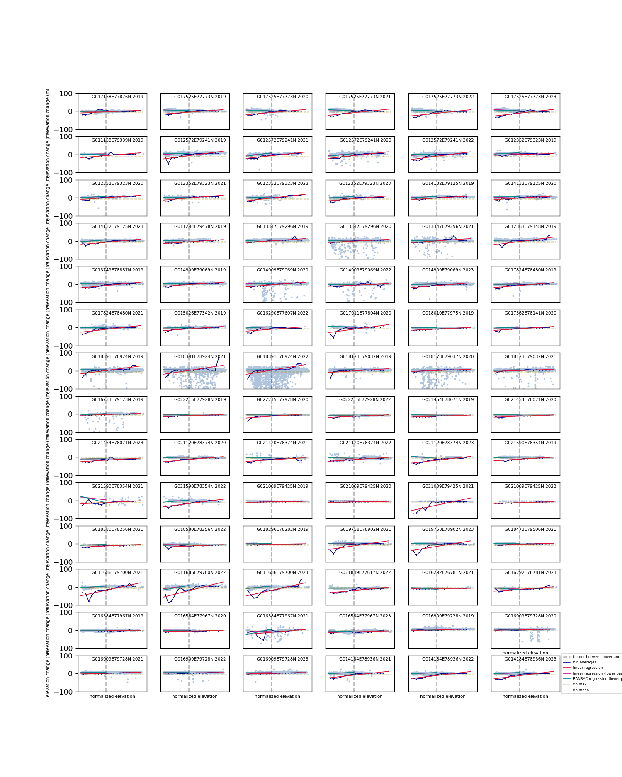

Figure - Features of non-surging glaciers.

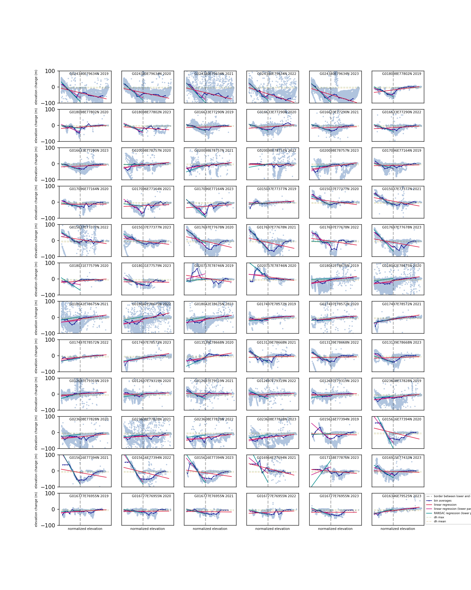

Figure - Features of surging glaciers.

1. **Results (and comparison with other studies)**

Here I present the full list of glaciers classified as surging in a comprehensive table including glacier name, probability with which it was classified as surging, whether or not the glacier was included in the training data (column “training data”), results of manual validation (column “validation”) after looking for signs of a surge in other studies (mainly Koch and Kääb but was just looking through the internet if I find a mention of this glacier surging in other case studies), on satellite imagery (Sentinel-2 in EO-Browser, therefore a terminus advance/sudden crevassing since 2018), ITS_LIVE velocities. The column “references” gives a reference if the glacier was found to be surging by someone else as well. There are two tables. One for the 5-year period, and one for results grouped by hydrological year. Only glaciers classified as surging are given in this supplementary file, otherwise the list would be never-ending (over 1600 glaciers). The full results of the classification are available for download on GitHub. False negatives were manually added to this list (glaciers that we know were surging during the study period, but were not classified as surging).

|  |  |  |  |  |  |  |
| --- | --- | --- | --- | --- | --- | --- |
| **results on analysis done on all ICESat-2 data** | | | | | | |
|  | **glacier_id** | **glac_name** | **probability** | **training_data** | **validation** | **source** |
| **814** | G016187E77275N | Polakkbreen | 0.9529375346884941 | 0 | 1 | Sund and others (2014) |
| **709** | G017096E77164N | Markhambreen | 0.9520721500731094 | 1 | 1 |  |
| **873** | G018098E77802N | Arnesenbreen | 0.9511732489742084 | 1 | 1 |  |
| **824** | G016633E77290N | Nathorstbreen | 0.950687534688494 | 1 | 1 |  |
| **802** | G015502E77425N | Sveitsarfonna | 0.9493054834064427 | 0 | 1 | - |
| **803** | G015616E77394N | Penckbreen | 0.9489507199810138 | 1 | 1 |  |
| **685** | G017697E77678N | Morsjnevbreen / Strongbreen | 0.945157972583932 | 1 | 1 |  |
| **1267** | G024340E79634N | Austfonna, - | 0.9392248255740492 | 1 | 1 |  |
| **327** | G013901E78579N | Wahlenbergbreen | 0.9391692079890198 | 0 | 1 | Sevestre (2018) |
| **288** | G013139E78668N | Osbornebreen | 0.9389564377152919 | 1 | 1 |  |
| **716** | G016777E76955N | Svalisbreen | 0.9335112514945638 | 1 | 1 |  |
| **1269** | G024396E79406N | Austfonna, - | 0.9064032245776177 | 0 | 1 |  |
| **1263** | G026458E79881N | Austfonna, - | 0.9051417232244162 | 0 | 1 |  |
| **273** | G012307E78697N | Aavatsmarkbreen | 0.8974895597958215 | 0 | 1 | Sevestre (2018) |
| **691** | G018031E77579N | Kvalbreen | 0.8837212129036356 | 1 | 1 |  |
| **792** | G015037E77377N | Recherchebreen | 0.8607183888391295 | 1 | 1 |  |
| **317** | G013747E78362N | Esmarkbreen | 0.8405812029054825 | 0 | 1 | - |
| **821** | G016915E77433N | Liestølbreen | 0.8294582220041988 | 1 | 1 |  |
| **1355** | G023016E77464N | - | 0.8212191393374161 | 0 | 0 |  |
| **715** | G016898E76901N | Vasilievbreen | 0.810141654535982 | 0 | 0 |  |
| **1406** | G023608E77828N | Stonebreen | 0.8054102523782426 | 1 | 1 |  |
| **593** | G014342E77910N | Austre Gronfjordbreen | 0.8010236970402497 | 0 | 0 |  |
| **1415** | G015900E77167N | Mülbacherbreen | 0.7887886937025257 | 0 | 0 |  |
| **1361** | G022867E77386N | Kvitkåpa SW | 0.7884248242514131 | 0 | 2 |  |
| **739** | G016482E76791N | Olsokbreen | 0.7847128496807064 | 0 | 2 |  |
| **677** | G016964E77694N | Scheelebreen | 0.7843724477314634 | 1 | 1 |  |
| **1369** | G022184E77709N | - | 0.7836220312154158 | 0 | 0 |  |
| **992** | G016598E79263N | Cookbreen | 0.7741422376669712 | 0 | 1 | - |
| **1368** | G022129E77665N | Veidebreen | 0.7681963547535609 | 0 | 0 |  |
| **1379** | G021526E77589N |  | 0.765844016170605 | 0 | 0 |  |
| **1116** | G012186E79547N | Emmabreen | 0.7656598507191571 | 0 | 1 | Alean and Hambrey (2017) |
| **1055** | G020757E78746N | Ganskijbreen | 0.7556309979966456 | 1 | 1 |  |
| **50** | G012697E79319N | Monacobreen | 0.7495714592101042 | 1 | 1 |  |
| **811** | G015857E77338N | Zawadzkibreen | 0.7468794875218658 | 0 | 1 | Sund and others (2014) |
| **232** | G012468E79076N | Blomstrandbreen | 0.7310818893193399 | 0 | 1 |  |
| **243** | G012520E78787N | Uversbreen | 0.7238215714870653 | 0 | 1 |  |
| **1342** | G022918E77824N | Seidbreen | 0.723173967594796 | 0 | 0 |  |
| **1230** | G020164E80193N |  | 0.7214528981413024 | 0 | 2 |  |
| **153** | G014532E79489N |  | 0.7027737001997545 | 0 | 0 |  |
| **1396** | G022338E77853N |  | 0.7016551888329386 | 0 | 0 |  |
| **1337** | G022869E77865N |  | 0.6986516444671134 | 0 | 0 |  |
| **1334** | G022417E77913N |  | 0.691155666527814 | 0 | 0 |  |
| **469** | G017583E78369N | Fimbulisen W | 0.690799538639607 | 0 | 0 |  |
| **346** | G014941E78875N |  | 0.6857699366387541 | 0 | 0 |  |
| **1004** | G016364E79743N | Åsgardfonna NW | 0.6851523621110849 | 0 | 2 |  |
| **761** | G015592E77097N | Hansbreen | 0.6835120340775029 | 0 | 0 |  |
| **900** | G017731E78159N | Skruisbreen | 0.6798262238352163 | 0 | 2 |  |
| **1340** | G023101E77888N | Albrechtbreen | 0.6760374587356528 | 0 | 0 |  |
| **816** | G016561E77390N |  | 0.6749304072692287 | 0 | 1 |  |
| **1105** | G014063E78811N |  | 0.6706931835371946 | 0 | 0 |  |
| **1088** | G018199E78191N | Elfenbeinbreen | 0.6692765719276695 | 0 | 2 |  |
| **718** | G016557E76915N | Mendelejevbreen | 0.6620641986445073 | 0 | 0 |  |
| **948** | G015689E78547N | Frostisen | 0.6423865774006396 | 0 | 0 |  |
| **897** | G017687E78107N | Sveigbreen | 0.6421111802101107 | 0 | 0 |  |
| **1257** | G025164E79993N | Austfonna, Nilsenbreen | 0.6386435968131156 | 0 | 2 |  |
| **1411** | G017158E77876N | Vallåkrabreen | 0.6383237809125053 | 1 | 1 |  |
| **1343** | G023062E77750N | Gandbreen N | 0.6383063220431107 | 0 | 0 |  |
| **823** | G016634E77343N | Dobrowolskibreen | 0.6266132451570819 | 0 | 1 |  |
| **826** | G016885E77574N | Doktorbreen | 0.6138388560716016 | 0 | 1 |  |
| **1348** | G023592E77662N | Kong Johans Bre | 0.6126281329027405 | 0 | 0 |  |
| **1258** | G025456E80055N | Austfonna, Sexebreen | 0.6056337939454179 | 0 | 0 |  |
| **1370** | G022032E77715N |  | 0.5960994288951611 | 0 | 0 |  |
| **1255** | G024143E79973N | Austfonna, Duvebreen | 0.5896475133529454 | 0 | 2 |  |
| **358** | G014869E79036N | Battyebreen | 0.589052221681525 | 0 | 0 |  |
| **706** | G017180E77206N | Crollbreen | 0.5877166488011325 | 0 | 1 |  |
| **1253** | G023229E79872N | Austfonna, - | 0.582125107949337 | 0 | 2 |  |
| **1094** | G018042E78675N | Negribreen | 0.5817188442132514 | 1 | 1 |  |
| **1388** | G021430E77541N | Skrentbreen | 0.5806978599962236 | 0 | 0 |  |
| **879** | G018079E77679N | Innifonna | 0.563224262545823 | 0 | 0 |  |
| **1174** | G011663E79770N | Hamiltonbreen | 0.5603701930235172 | 0 | 0 |  |
| **1252** | G021502E79897N | Bodleybreen | 0.5587669281445655 | 0 | 2 |  |
| **1351** | G023386E77490N | Pettersenbreen | 0.5548861159702355 | 0 | 2 |  |
| **1285** | G018751E79906N | Backabreen | 0.5494125259705098 | 0 | 0 |  |
| **1344** | G023134E77724N | Gandbreen S | 0.546919568390121 | 0 | 0 |  |
| **721** | G016435E76929N | Chomjakovbreen | 0.5445875193685676 | 0 | 0 |  |
| **594** | G014257E77913N | Vestre Gronfjordbreen | 0.5432636938249475 | 0 | 0 |  |
| **1254** | G023619E79932N | Austfonna, - | 0.542680251005169 | 0 | 2 |  |
| **999** | G016346E79525N | Midtbreen | 0.5350583759185323 | 1 | 1 |  |
| **239** | G013248E78855N | Infantfonna | 0.5326788655209166 | 0 | 0 |  |
| **1366** | G022015E77578N |  | 0.5325493385319876 | 0 | 0 |  |
| **1380** | G021338E77589N |  | 0.5306513381538976 | 0 | 0 |  |
| **1262** | G026669E79935N | Austfonna, - | 0.527446576335112 | 0 | 0 |  |

|  |  |  |  |  |  |  |
| --- | --- | --- | --- | --- | --- | --- |
| **results of analysis done on glaciers per hydrological year** | | | | | | |
|  | **glac_name** | **glacier_id** | **year** | **surging** | **probability** | **training** |
| **0** | Monacobreen | G012697E79319N | 2019 | 1 | 0.5495112692890027 | 1 |
| **1** | Monacobreen | G012697E79319N | 2020 | 1 | 0.8980733177462052 | 1 |
| **2** | Monacobreen | G012697E79319N | 2021 | 1 | 0.9229530504993306 | 1 |
| **3** | Monacobreen | G012697E79319N | 2022 | 1 | 0.8982263956732783 | 1 |
| **4** | Monacobreen | G012697E79319N | 2023 | 1 | 0.8767809974639619 | 1 |
| **5** | Vonbreen | G013470E79201N | 2021 | 1 | 0.6626685809718363 |  |
| **6** | Blomstrandbreen | G012468E79076N | 2019 | 1 | 0.8178124749597936 |  |
| **7** | Blomstrandbreen | G012468E79076N | 2020 | 1 | 0.8696375762135891 |  |
| **8** | Blomstrandbreen | G012468E79076N | 2021 | 1 | 0.8336825004206041 |  |
| **9** | Blomstrandbreen | G012468E79076N | 2022 | 1 | 0.7412018960100505 |  |
| **10** | Blomstrandbreen | G012468E79076N | 2023 | 1 | 0.8538052315673145 |  |
| **11** | Infantfonna | G013248E78855N | 2023 | 1 | 0.653391929683654 |  |
| **12** | Uversbreen | G012520E78787N | 2019 | 1 | 0.8244880792202702 |  |
| **13** | Uversbreen | G012520E78787N | 2020 | 1 | 0.8140899042957797 |  |
| **14** | Uversbreen | G012520E78787N | 2021 | 1 | 0.8173402739082194 |  |
| **15** | Uversbreen | G012520E78787N | 2022 | 1 | 0.7951721553780307 |  |
| **16** | Uversbreen | G012520E78787N | 2023 | 1 | 0.7044911367836966 |  |
| **17** | Aavatsmarkbreen | G012307E78697N | 2019 | 1 | 0.9335594336535478 |  |
| **18** | Aavatsmarkbreen | G012307E78697N | 2020 | 1 | 0.9542083403292985 |  |
| **19** | Aavatsmarkbreen | G012307E78697N | 2021 | 1 | 0.849083790767048 |  |
| **20** | Aavatsmarkbreen | G012307E78697N | 2022 | 1 | 0.913079623158105 |  |
| **21** | Aavatsmarkbreen | G012307E78697N | 2023 | 1 | 0.8795266176018524 |  |
| **22** | Konowbreen | G012918E78620N | 2022 | 1 | 0.5446524620380976 |  |
| **23** | Konowbreen | G012918E78620N | 2023 | 1 | 0.6872664024992301 |  |
| **24** | Dahlbreen | G012670E78658N | 2021 | 1 | 0.5279282088444528 |  |
| **25** | Dahlbreen | G012670E78658N | 2022 | 1 | 0.6780668936983569 |  |
| **26** | Dahlbreen | G012670E78658N | 2023 | 1 | 0.6773217189127865 |  |
| **27** | Osbornebreen | G013139E78668N | 2020 | 1 | 0.9789701413397903 | 1 |
| **28** | Osbornebreen | G013139E78668N | 2021 | 1 | 0.9924340282593223 | 1 |
| **29** | Osbornebreen | G013139E78668N | 2022 | 1 | 0.9997777777777778 | 1 |
| **30** | Osbornebreen | G013139E78668N | 2023 | 1 | 0.9994920634920635 | 1 |
| **31** | Osbornebreen | G013271E78658N | 2021 | 1 | 0.5326223167840312 |  |
| **32** | Osbornebreen | G013271E78658N | 2022 | 1 | 0.61904274483237 |  |
| **33** | Esmarkbreen | G013747E78362N | 2020 | 1 | 0.7411347499915243 |  |
| **34** | Esmarkbreen | G013747E78362N | 2021 | 1 | 0.8295408857339226 |  |
| **35** | Esmarkbreen | G013747E78362N | 2022 | 1 | 0.7996686778365147 |  |
| **36** | Esmarkbreen | G013747E78362N | 2023 | 1 | 0.8086708507758121 |  |
| **37** | Wahlenbergbreen | G013901E78579N | 2019 | 1 | 0.9748826786102327 |  |
| **38** | Wahlenbergbreen | G013901E78579N | 2020 | 1 | 0.9504302294017982 |  |
| **39** | Wahlenbergbreen | G013901E78579N | 2021 | 1 | 0.9598454994227155 |  |
| **40** | Wahlenbergbreen | G013901E78579N | 2022 | 1 | 0.9899798737697344 |  |
| **41** | Wahlenbergbreen | G013901E78579N | 2023 | 1 | 0.9944695711122955 |  |
| **42** | Lisbetbreen | G014909E79069N | 2021 | 1 | 0.6434328971606093 |  |
| **43** | Tunabreen | G017497E78572N | 2019 | 1 | 0.6335407742744129 | 1 |
| **44** | Tunabreen | G017497E78572N | 2020 | 1 | 0.7041424693537766 | 1 |
| **45** | Tunabreen | G017497E78572N | 2022 | 1 | 0.6107338211241038 | 1 |
| **46** | Vestre Gronfjordbreen | G014257E77913N | 2023 | 1 | 0.6461045250707202 |  |
| **47** |  | G014123E77878N | 2023 | 1 | 0.560079861485557 |  |
| **48** | Paulabreen | G017399E77693N | 2022 | 1 | 0.5296613108968615 |  |
| **49** | Paulabreen | G017399E77693N | 2023 | 1 | 0.5242658334763919 |  |
| **50** | Morsjnevbreen / Strongbreen | G017697E77678N | 2019 | 1 | 0.9574618711928444 |  |
| **51** | Morsjnevbreen / Strongbreen | G017697E77678N | 2020 | 1 | 0.9751117653727386 | 1 |
| **52** | Morsjnevbreen / Strongbreen | G017697E77678N | 2021 | 1 | 0.9860616371395083 | 1 |
| **53** | Morsjnevbreen / Strongbreen | G017697E77678N | 2022 | 1 | 0.9789343265502009 | 1 |
| **54** | Morsjnevbreen / Strongbreen | G017697E77678N | 2023 | 1 | 0.9654854182914224 | 1 |
| **55** | Kvalbreen | G018031E77579N | 2019 | 1 | 0.5958671752283815 |  |
| **56** | Kvalbreen | G018031E77579N | 2020 | 1 | 0.7062886497006654 | 1 |
| **57** | Kvalbreen | G018031E77579N | 2021 | 1 | 0.9975742240215926 |  |
| **58** | Markhambreen | G017096E77164N | 2019 | 1 | 1.0 | 1 |
| **59** | Markhambreen | G017096E77164N | 2020 | 1 | 0.9976818516880437 | 1 |
| **60** | Markhambreen | G017096E77164N | 2021 | 1 | 0.9439620780706681 | 1 |
| **61** | Markhambreen | G017096E77164N | 2023 | 1 | 0.986349838136977 | 1 |
| **62** | Vasilievbreen | G016898E76901N | 2019 | 1 | 0.9129567801692058 |  |
| **63** | Vasilievbreen | G016898E76901N | 2020 | 1 | 0.8449534299604782 |  |
| **64** | Vasilievbreen | G016898E76901N | 2022 | 1 | 0.6256478448597852 |  |
| **65** | Vasilievbreen | G016898E76901N | 2023 | 1 | 0.8939264982117011 |  |
| **66** | Svalisbreen | G016777E76955N | 2019 | 1 | 0.5734837783227803 | 1 |
| **67** | Svalisbreen | G016777E76955N | 2020 | 1 | 0.8787229979402055 | 1 |
| **68** | Svalisbreen | G016777E76955N | 2021 | 1 | 0.9147374210247543 | 1 |
| **69** | Svalisbreen | G016777E76955N | 2022 | 1 | 0.9714240383940911 | 1 |
| **70** | Svalisbreen | G016777E76955N | 2023 | 1 | 0.9876891962951584 | 1 |
| **71** | Mendelejevbreen | G016557E76915N | 2020 | 1 | 0.6744043197001953 |  |
| **72** | Mendelejevbreen | G016557E76915N | 2021 | 1 | 0.6391071417644438 |  |
| **73** | Mendelejevbreen | G016557E76915N | 2022 | 1 | 0.6401413821373515 |  |
| **74** | Mendelejevbreen | G016557E76915N | 2023 | 1 | 0.6761838242699462 |  |
| **75** | Olsokbreen | G016482E76791N | 2019 | 1 | 0.5936588795826637 |  |
| **76** | Olsokbreen | G016482E76791N | 2020 | 1 | 0.7328139065116193 |  |
| **77** | Olsokbreen | G016482E76791N | 2021 | 1 | 0.6897233137648295 |  |
| **78** | Olsokbreen | G016482E76791N | 2022 | 1 | 0.8396597229399312 |  |
| **79** | Olsokbreen | G016482E76791N | 2023 | 1 | 0.8552382713164812 |  |
| **80** | Vasilievbreen | G016757E76881N | 2021 | 1 | 0.7927519604057945 |  |
| **81** | Vasilievbreen | G016757E76881N | 2022 | 1 | 0.794877309526256 |  |
| **82** | Vasilievbreen | G016757E76881N | 2023 | 1 | 0.5466460203474149 |  |
| **83** | Recherchebreen | G015037E77377N | 2019 | 1 | 0.6230193146804165 | 1 |
| **84** | Recherchebreen | G015037E77377N | 2020 | 1 | 0.9233521707571409 | 1 |
| **85** | Recherchebreen | G015037E77377N | 2021 | 1 | 0.8568868726350217 | 1 |
| **86** | Recherchebreen | G015037E77377N | 2022 | 1 | 0.8993836245995489 | 1 |
| **87** | Recherchebreen | G015037E77377N | 2023 | 1 | 0.9296451968275787 | 1 |
| **88** | Sveitsarfonna | G015502E77425N | 2019 | 1 | 0.9750291785941965 |  |
| **89** | Sveitsarfonna | G015502E77425N | 2020 | 1 | 0.6632688839633226 |  |
| **90** | Penckbreen | G015616E77394N | 2019 | 1 | 0.9928740740740741 | 1 |
| **91** | Penckbreen | G015616E77394N | 2020 | 1 | 0.9907805373058315 | 1 |
| **92** | Penckbreen | G015616E77394N | 2021 | 1 | 0.9920852992105933 | 1 |
| **93** | Penckbreen | G015616E77394N | 2022 | 1 | 0.9894749817502758 | 1 |
| **94** | Penckbreen | G015616E77394N | 2023 | 1 | 0.9923443722943723 | 1 |
| **95** | Zawadzkibreen | G015857E77338N | 2019 | 1 | 0.8486536700330973 |  |
| **96** | Zawadzkibreen | G015857E77338N | 2020 | 1 | 0.8585784571149968 |  |
| **97** | Zawadzkibreen | G015857E77338N | 2021 | 1 | 0.8655102303097658 |  |
| **98** | Zawadzkibreen | G015857E77338N | 2022 | 1 | 0.8222960044389271 |  |
| **99** | Zawadzkibreen | G015857E77338N | 2023 | 1 | 0.8237436746690212 |  |
| **100** | Polakkbreen | G016187E77275N | 2019 | 1 | 0.9902435151604896 |  |
| **101** | Polakkbreen | G016187E77275N | 2020 | 1 | 0.9280442856540795 |  |
| **102** | Polakkbreen | G016187E77275N | 2021 | 1 | 0.9886550908718365 |  |
| **103** | Polakkbreen | G016187E77275N | 2022 | 1 | 0.9886550908718365 |  |
| **104** | Polakkbreen | G016187E77275N | 2023 | 1 | 0.9827779477043708 |  |
| **105** | Liestølbreen | G016915E77433N | 2022 | 1 | 0.9251364469815024 |  |
| **106** | Liestølbreen | G016915E77433N | 2023 | 1 | 0.9689245900399586 | 1 |
| **107** | Dobrowolskibreen | G016634E77343N | 2019 | 1 | 0.7218111739269346 |  |
| **108** | Dobrowolskibreen | G016634E77343N | 2020 | 1 | 0.7197994472325545 |  |
| **109** | Dobrowolskibreen | G016634E77343N | 2021 | 1 | 0.7152722136705307 |  |
| **110** | Dobrowolskibreen | G016634E77343N | 2022 | 1 | 0.730610888517216 |  |
| **111** | Dobrowolskibreen | G016634E77343N | 2023 | 1 | 0.6834366203538662 |  |
| **112** | Nathorstbreen | G016633E77290N | 2019 | 1 | 0.9977647298235534 | 1 |
| **113** | Nathorstbreen | G016633E77290N | 2020 | 1 | 0.9929991924283719 | 1 |
| **114** | Nathorstbreen | G016633E77290N | 2021 | 1 | 0.9698803380714075 | 1 |
| **115** | Nathorstbreen | G016633E77290N | 2022 | 1 | 0.9866502102057904 | 1 |
| **116** | Nathorstbreen | G016633E77290N | 2023 | 1 | 0.9738806210271445 | 1 |
| **117** | Nuddbreen / Strongbreen | G017333E77537N | 2023 | 1 | 0.5318047498116993 |  |
| **118** | Doktorbreen | G016885E77574N | 2021 | 1 | 0.5429832613597371 |  |
| **119** | Doktorbreen | G016885E77574N | 2022 | 1 | 0.6748063454020871 |  |
| **120** | Doktorbreen | G016885E77574N | 2023 | 1 | 0.6562941525472487 |  |
| **121** | Arnesenbreen | G018098E77802N | 2019 | 1 | 0.9682712316130037 | 1 |
| **122** | Ingerbreen | G018231E77758N | 2021 | 1 | 0.615295895071099 |  |
| **123** | Innifonna | G018079E77679N | 2020 | 1 | 0.5278272083241564 |  |
| **124** | Richardsbreen | G017893E77712N | 2019 | 1 | 0.5293521832228455 |  |
| **125** | Richardsbreen | G017893E77712N | 2020 | 1 | 0.5392713028620293 |  |
| **126** | Mittag-Lefflerbreen | G017025E78797N | 2022 | 1 | 0.6458964991102507 |  |
| **127** | Chydeniusbreen | G017693E79137N | 2022 | 1 | 0.5298873391539849 |  |
| **128** | Kantbreen | G017730E79297N | 2020 | 1 | 0.5364318970791321 |  |
| **129** | Sonklarbreen | G020098E78757N | 2021 | 1 | 0.6192262344321 | 1 |
| **130** | Sonklarbreen | G020098E78757N | 2022 | 1 | 0.6103175233704705 | 1 |
| **131** | Sonklarbreen | G020098E78757N | 2023 | 1 | 0.6257903942901188 | 1 |
| **132** | Ganskijbreen | G020757E78746N | 2019 | 1 | 0.7157628630378932 | 1 |
| **133** | Ganskijbreen | G020757E78746N | 2020 | 1 | 0.6844030366288982 | 1 |
| **134** | Ganskijbreen | G020757E78746N | 2021 | 1 | 0.7685690798060673 |  |
| **135** | Petermannbreen | G018419E78498N | 2020 | 1 | 0.574764723709319 |  |
| **136** | Petermannbreen | G018419E78498N | 2022 | 1 | 0.7111328426160142 |  |
| **137** | Petermannbreen | G018419E78498N | 2023 | 1 | 0.7620870731514391 |  |
| **138** | Negribreen | G018042E78675N | 2019 | 1 | 0.6400683344633358 | 1 |
| **139** | Negribreen | G018042E78675N | 2020 | 1 | 0.8443730499009009 | 1 |
| **140** | Negribreen | G018042E78675N | 2021 | 1 | 0.8631098088357121 | 1 |
| **141** | Negribreen | G018042E78675N | 2022 | 1 | 0.8566629539793011 | 1 |
| **142** | Negribreen | G018042E78675N | 2023 | 1 | 0.7887576089509803 | 1 |
| **143** | Sefströmbreen | G013819E78747N | 2021 | 1 | 0.5572680944087637 |  |
| **144** | Sefströmbreen | G013819E78747N | 2022 | 1 | 0.5842080158664189 |  |
| **145** | Sefströmbreen | G013819E78747N | 2023 | 1 | 0.5893751708785492 |  |
| **146** |  | G012186E79547N | 2019 | 1 | 0.7741456572250678 |  |
| **147** |  | G012186E79547N | 2023 | 1 | 0.8706494278123069 |  |
| **148** | Smeerenburgbreen | G011600E79552N | 2023 | 1 | 0.5703352441557792 |  |
| **149** | Svitjodbreen | G011686E79700N | 2019 | 1 | 0.5457089480495759 |  |
| **150** | Svitjodbreen | G011686E79700N | 2021 | 1 | 0.5651587423175287 |  |
| **151** | Svitjodbreen | G011686E79700N | 2023 | 1 | 0.5853060830702301 |  |
| **152** |  | G011663E79770N | 2019 | 1 | 0.5483261204799925 |  |
| **153** | Lilliehøøkbreen | G011860E79450N | 2023 | 1 | 0.8080300267049461 |  |
| **154** | Søre Franklinbreen | G019797E80009N | 2020 | 1 | 0.5420902284991326 |  |
| **155** | Søre Franklinbreen | G019797E80009N | 2022 | 1 | 0.5895682231440966 |  |
| **156** |  | G020164E80193N | 2020 | 1 | 0.5515665020687501 |  |
| **157** | Bodleybreen | G021502E79897N | 2021 | 1 | 0.6140505708711896 |  |
| **158** | Bodleybreen | G021502E79897N | 2023 | 1 | 0.5285258133189912 |  |
| **159** | Austfonna, - | G026669E79935N | 2019 | 1 | 0.604836918908633 |  |
| **160** | Austfonna, - | G026669E79935N | 2022 | 1 | 0.5280964926732523 |  |
| **161** | Austfonna, - | G026458E79881N | 2019 | 1 | 0.5757098624957122 |  |
| **162** | Austfonna, - | G026458E79881N | 2020 | 1 | 0.9404256642166995 |  |
| **163** | Austfonna, - | G026458E79881N | 2021 | 1 | 0.9543696163861235 |  |
| **164** | Austfonna, - | G026458E79881N | 2022 | 1 | 0.8947218135958929 |  |
| **165** | Austfonna, - | G026458E79881N | 2023 | 1 | 0.9533111231769201 |  |
| **166** | Austfonna, - | G024340E79634N | 2019 | 1 | 0.9749992556090852 | 1 |
| **167** | Austfonna, - | G024340E79634N | 2020 | 1 | 0.9733925272497255 | 1 |
| **168** | Austfonna, - | G024340E79634N | 2021 | 1 | 0.9758791396139694 | 1 |
| **169** | Austfonna, - | G024340E79634N | 2022 | 1 | 0.9652886634234932 | 1 |
| **170** | Austfonna, - | G024340E79634N | 2023 | 1 | 0.952000066932265 | 1 |
| **171** | Austfonna, - | G024396E79406N | 2019 | 1 | 0.9438436872605832 |  |
| **172** | Austfonna, - | G024396E79406N | 2020 | 1 | 0.9375860658059476 |  |
| **173** | Austfonna, - | G024396E79406N | 2021 | 1 | 0.950273978886887 |  |
| **174** | Austfonna, - | G024396E79406N | 2022 | 1 | 0.9524413367735349 |  |
| **175** | Austfonna, - | G024396E79406N | 2023 | 1 | 0.9529781333103313 |  |
| **176** | Freemanbreen | G021590E78354N | 2023 | 1 | 0.5382755682956225 |  |
| **177** | Besselsbreen | G021460E78472N | 2021 | 1 | 0.8429366611504978 |  |
| **178** | Besselsbreen | G021460E78472N | 2022 | 1 | 0.6383220901864546 |  |
| **179** | Besselsbreen | G021460E78472N | 2023 | 1 | 0.623598264406797 |  |
| **180** | Albrechtbreen | G023101E77888N | 2021 | 1 | 0.5424049892131216 |  |
| **181** | Albrechtbreen | G023101E77888N | 2022 | 1 | 0.6892736061873117 |  |
| **182** | Albrechtbreen | G023101E77888N | 2023 | 1 | 0.652428994451068 |  |
| **183** | Seidbreen | G022918E77824N | 2023 | 1 | 0.7559050215469809 |  |
| **184** | Gandbreen N | G023062E77750N | 2020 | 1 | 0.5753253208597048 |  |
| **185** | Gandbreen N | G023062E77750N | 2023 | 1 | 0.5373177335964059 |  |
| **186** | Gandbreen S | G023134E77724N | 2019 | 1 | 0.5622882700152962 |  |
| **187** | Deltabreen | G023294E77648N | 2020 | 1 | 0.5910500200316883 |  |
| **188** | Deltabreen | G023294E77648N | 2021 | 1 | 0.5657773766395191 |  |
| **189** | Deltabreen | G023294E77648N | 2022 | 1 | 0.5284993155774546 |  |
| **190** | Deltabreen | G023294E77648N | 2023 | 1 | 0.5465678373446139 |  |
| **191** | Kong Johans Bre | G023592E77662N | 2019 | 1 | 0.6714585150887665 |  |
| **192** | Kong Johans Bre | G023592E77662N | 2020 | 1 | 0.7028202778826588 |  |
| **193** | Kong Johans Bre | G023592E77662N | 2021 | 1 | 0.8050076978666576 |  |
| **194** |  | G023016E77464N | 2019 | 1 | 0.5949617184029214 |  |
| **195** |  | G022867E77386N | 2022 | 1 | 0.6862019176897076 |  |
| **196** | Veidebreen | G022129E77665N | 2022 | 1 | 0.8630983233952101 |  |
| **197** | Veidebreen | G022129E77665N | 2023 | 1 | 0.7654656417650724 |  |
| **198** | Kuhrbreen | G021849E77617N | 2019 | 1 | 0.5793551786315994 |  |
| **199** | Kuhrbreen | G021849E77617N | 2022 | 1 | 0.580602611381272 |  |
| **200** | Kuhrbreen | G021849E77617N | 2023 | 1 | 0.6794366016842049 |  |
| **201** | Stonebreen | G023608E77828N | 2019 | 1 | 0.8199601822516722 | 1 |
| **202** | Stonebreen | G023608E77828N | 2020 | 1 | 0.8306248309059253 | 1 |
| **203** | Stonebreen | G023608E77828N | 2021 | 1 | 0.8420796412551768 | 1 |
| **204** | Stonebreen | G023608E77828N | 2022 | 1 | 0.9086294899739814 | 1 |
| **205** | Stonebreen | G023608E77828N | 2023 | 1 | 0.8343362807379148 | 1 |
| **206** | Austre Torellbreen | G015444E77229N | 2022 | 1 | 0.7031242350003805 |  |
| **207** | Austre Torellbreen | G015444E77229N | 2023 | 1 | 0.5795849948627809 |  |
| **208** | Paierlbreen | G015696E77195N | 2022 | 1 | 0.5475205912736479 |  |
| **209** | Paierlbreen | G015696E77195N | 2023 | 1 | 0.6914996755418843 |  |
| **210** | Mülbacherbreen | G015900E77167N | 2020 | 1 | 0.6495126644885495 |  |
| **211** | Mülbacherbreen | G015900E77167N | 2021 | 1 | 0.7056482967304791 |  |
| **212** | Mülbacherbreen | G015900E77167N | 2022 | 1 | 0.660616970986484 |  |
| **213** | Mülbacherbreen | G015900E77167N | 2023 | 1 | 0.5752543113224716 |  |
| **214** | Hornbreen | G016807E77171N | 2022 | 1 | 0.5301743944873021 |  |
| **215** | Borebreen | G013724E78479N | 2023 | 1 | 0.7253004475465884 |  |

1. **Outdated RGI outlines causing false positives.**

The RGI outlines come from the year XXX. Since then, many glaciers have retreated and the outlines are now outdated. This can cause multiple problems also in misclassification.

Mendelejevbreen was classified as surging all years between except for 2019. In 2019 the tracks did not include data from the (now) fjord. This is what the plots for the other years (example on 2023) looked like:

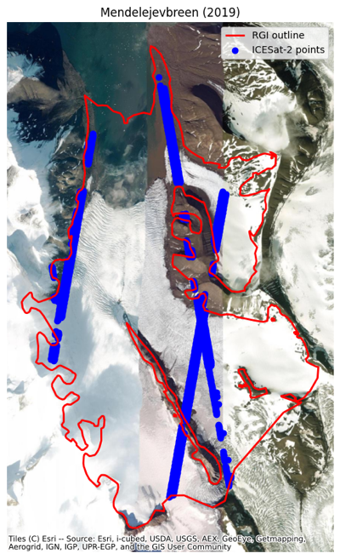 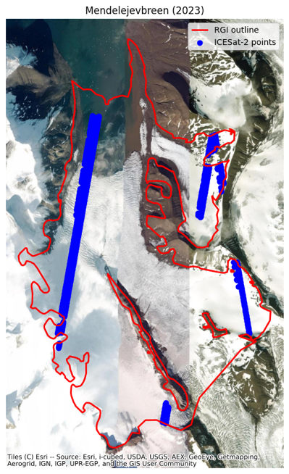  
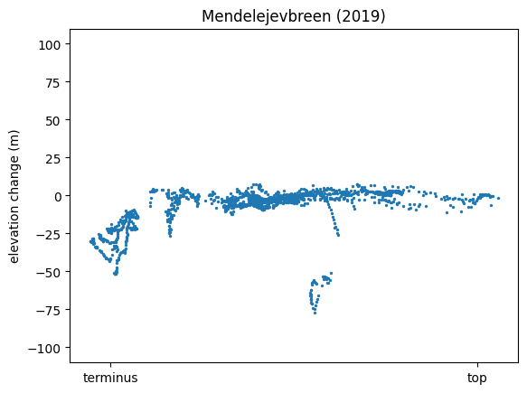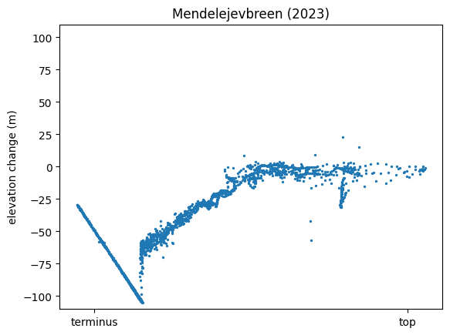

1. **Elevation change plots for a couple discussed glaciers**

We can argue that there is a visible surge bulge on Deltabreen in 2023 before it started surging. The terminus and outdated RGI outlines are causing a bit of a mess at the terminus, but the surge bulge is visibly forming throughout the years and it is quite large in 2023. In 2024, Deltabreen started surging.

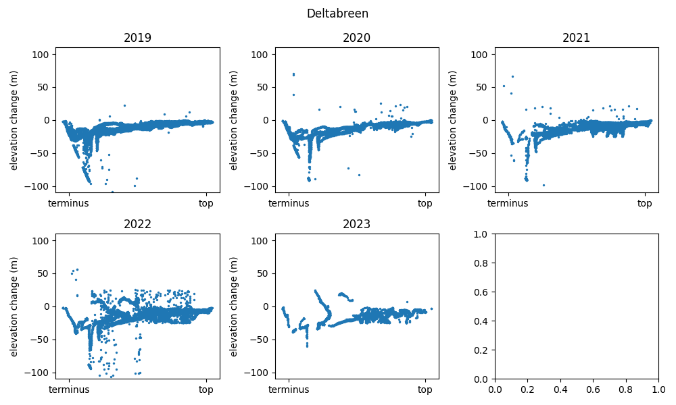

Sefstrombreen also has a surge bulge visible and was classified as surging since 2021. 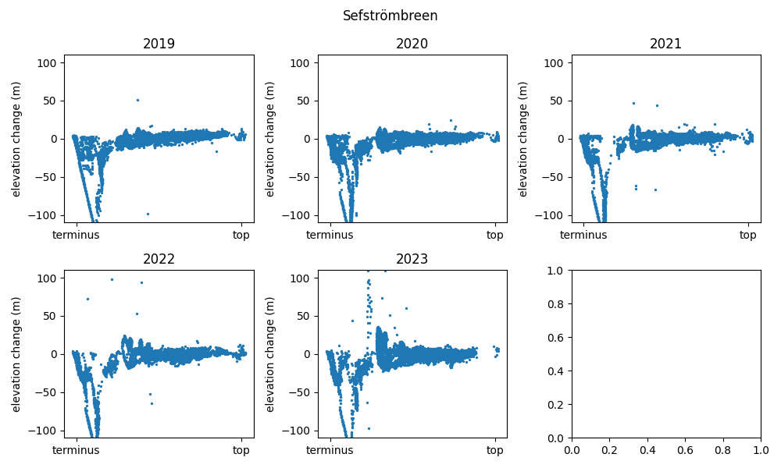

Let’s be on the lookout for: Austre Torellbreen, Kuhrbreen